JAVA LAB PROGRAM

Submitted by,

Tamilvanan B.

2018503566.

MO Batch.

09-29-2020.

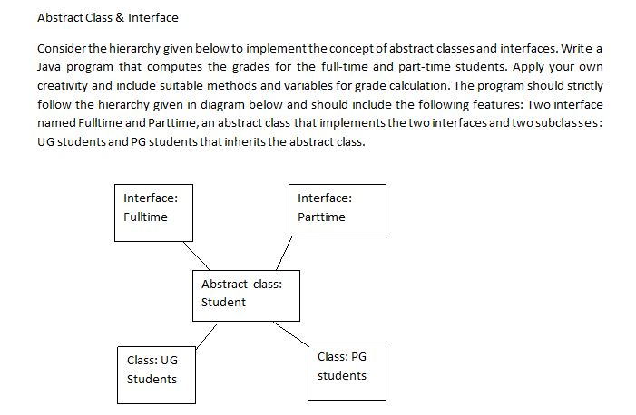

Program

import java.util.Scanner;

interface fullTime{

int max = 100;

String name = "";

int reg = 0;

int[] arr = new int[10];

int marks = 0;

int computefulltime(int arr[]);

}

interface partTime{

int max = 50;

String name = "";

int reg = 0;

int[] arr = new int[10];

int computeparttime(int arr[]);

}

abstract class Student implements fullTime,partTime {

@Override

public int computefulltime(int arr[]){

int marks = 0;

for(int i = 0; i < arr.length; i++){

marks += arr[i];

}

return marks/5;

}

@Override

public int computeparttime(int arr[]){

int marks = 0;

for(int i = 0; i < arr.length; i++){

marks += arr[i];

}

return marks/3;

}

}

class Ug extends Student{

public int computefulltime(int[] arr){

int marks = 0;

for(int i = 0; i < arr.length; i++){

marks += arr[i];

}

return marks/5;

}

public int computeparttime(int[] arr){

int marks = 0;

for(int i = 0; i < arr.length; i++){

marks += arr[i];

}

return marks/5;

}

void result(int res){

int marks = res;

if(marks >= 50 && marks <= 60){

System.out.print("B");

}

else if(marks >= 61 && marks <= 70){

System.out.print("B+");

}

else if(marks >= 71 && marks <= 80){

System.out.print("A");

}

else if(marks >= 81 && marks <= 90){

System.out.print("A+");

}

else if(marks >= 91){

System.out.print("O");

}

else{

System.out.print("Below average");

}

}

}

class Pg extends Student{

public int computefulltime(int arr[]){

int marks = 0;

for(int i = 0; i < arr.length; i++){

marks += arr[i];

}

return marks/3;

}

public int computeparttime(int arr[]){

int marks = 0;

for(int i = 0; i < arr.length; i++){

marks += arr[i];

}

return marks/3;

}

void result(int res){

int marks = res;

if(marks >= 20 && marks <= 30){

System.out.print("B");

}

else if(marks >= 31 && marks <= 40){

System.out.print("A");

}

else if(marks >= 41 && marks <= 50){

System.out.print("O");

}

else{

System.out.print("Below average");

}

}

}

public class Compute{

public static void main(String... arrgs){

Scanner sc = new Scanner(System.in);

int choice;

while(true){

System.out.print("\n1. Compute\n2. Exit\nEnter choice: ");

choice = sc.nextInt();

if(choice == 1){

System.out.print("Enter name: ");

String name = sc.next();

System.out.print("Enter roll number: ");

int reg = sc.nextInt();

System.out.print("Full Time (0) or Part Time (1): ");

int c = sc.nextInt();

if(c == 0){

System.out.print("Ug (0) or Pg (1): ");

int n = sc.nextInt();

if(n == 0){

int[] arr = new int[5];

for(int i = 0; i < 5; i++){

System.out.print("Subject " + String.valueOf(i + 1) + ": ");

arr[i] = sc.nextInt();

}

Ug obj = new Ug();

int res = obj.computefulltime(arr);

System.out.print("Grade obtained: ");

obj.result(res);

}

else if(n == 1){

int[] arr = new int[3];

for(int i = 0; i < 3; i++){

System.out.print("Subject " + String.valueOf(i + 1) + ": ");

arr[i] = sc.nextInt();

}

Pg obj = new Pg();

int res = obj.computefulltime(arr);

System.out.print("Grade obtained: ");

obj.result(res);

}

}

else if (c == 1){

System.out.print("Ug (0) or Pg (1): ");

int n = sc.nextInt();

if(n == 0){

int[] arr = new int[5];

for(int i = 0; i < 5; i++){

System.out.print("Subject " + String.valueOf(i + 1) + ": ");

arr[i] = sc.nextInt();

}

Ug obj = new Ug();

int res = obj.computeparttime(arr);

System.out.print("Grade obtained: ");

obj.result(res);

}

else if(n == 1){

int[] arr = new int[3];

for(int i = 0; i < 3; i++){

System.out.print("Subject " + String.valueOf(i + 1) + ": ");

arr[i] = sc.nextInt();

}

Pg obj = new Pg();

int res = obj.computeparttime(arr);

System.out.print("Grade obtained: ");

obj.result(res);

}

}

}

else if(choice == 2){

break;

}

}

}

}

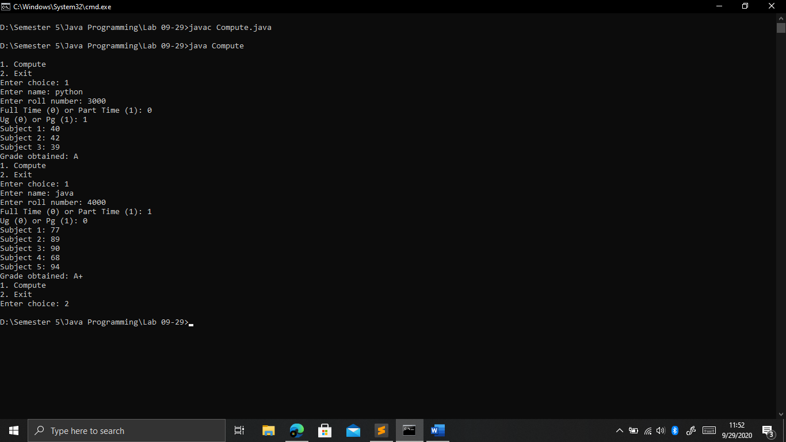Output